[ Insert official UPAEP logo ]
UPAEP · Decanato de Ingenierías
EVIDENCE — SPR-T1
End-to-end integration test
SmartGreenAI: Cilantro Crop

1. Task information
Task ID | SPR-T1
User Story | Sprint-level task
Sprint | Sprint 2 (2026-09-21 – 2026-10-09)
Week | Week 3
Responsible | Whole team (facilitated by Jorge)
Peer reviewer | Whole team
Planned / actual hours | 10 h / 10 h (2 h per member)
Completed on | October 8, 2026
Status | Done

2. Task description
Run the complete flow with the whole team: registered sensor, cloud transmission, storage, API, threshold screen and actuator panel. Record a short video or screenshots of every step.

3. Completion conditions
✓ Condition 1: Complete flow executed from registered sensor to actuator panel.
How it was verified: The complete flow was executed from the registered sensor to the actuator panel: registry → simulator transmission → storage → API → threshold screen → actuator panel.
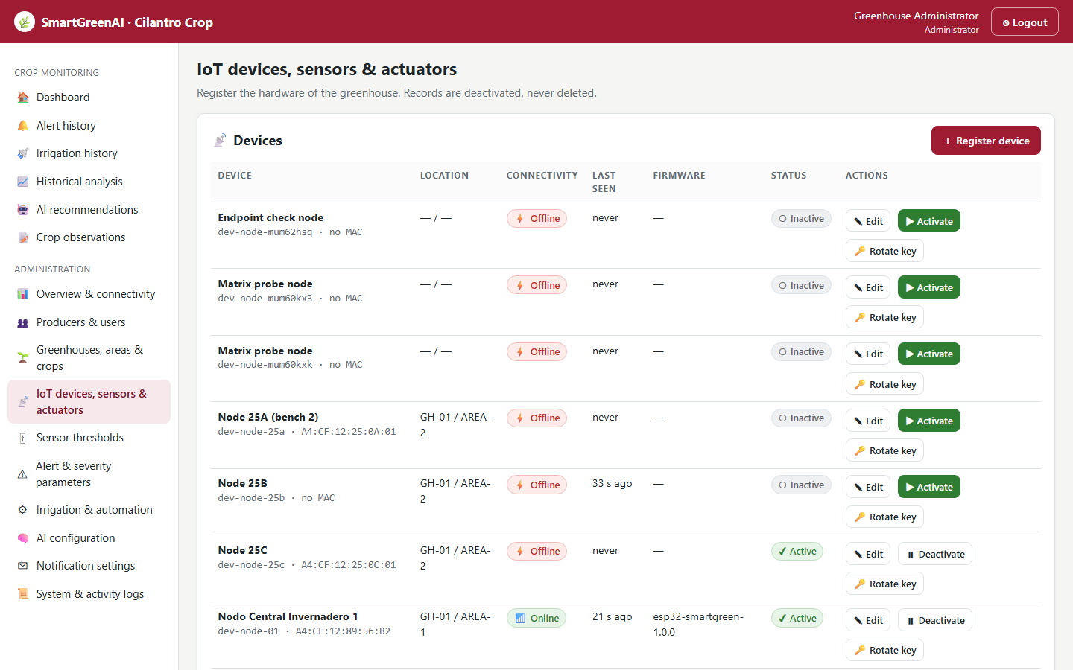
Figure SPR-T1-1. Step 1 — registered node dev-node-01 with its 8 sensors and 4 actuators (US-25). (Sprint2_SPR-T1_End-To-End_Integration_Test_1.png)
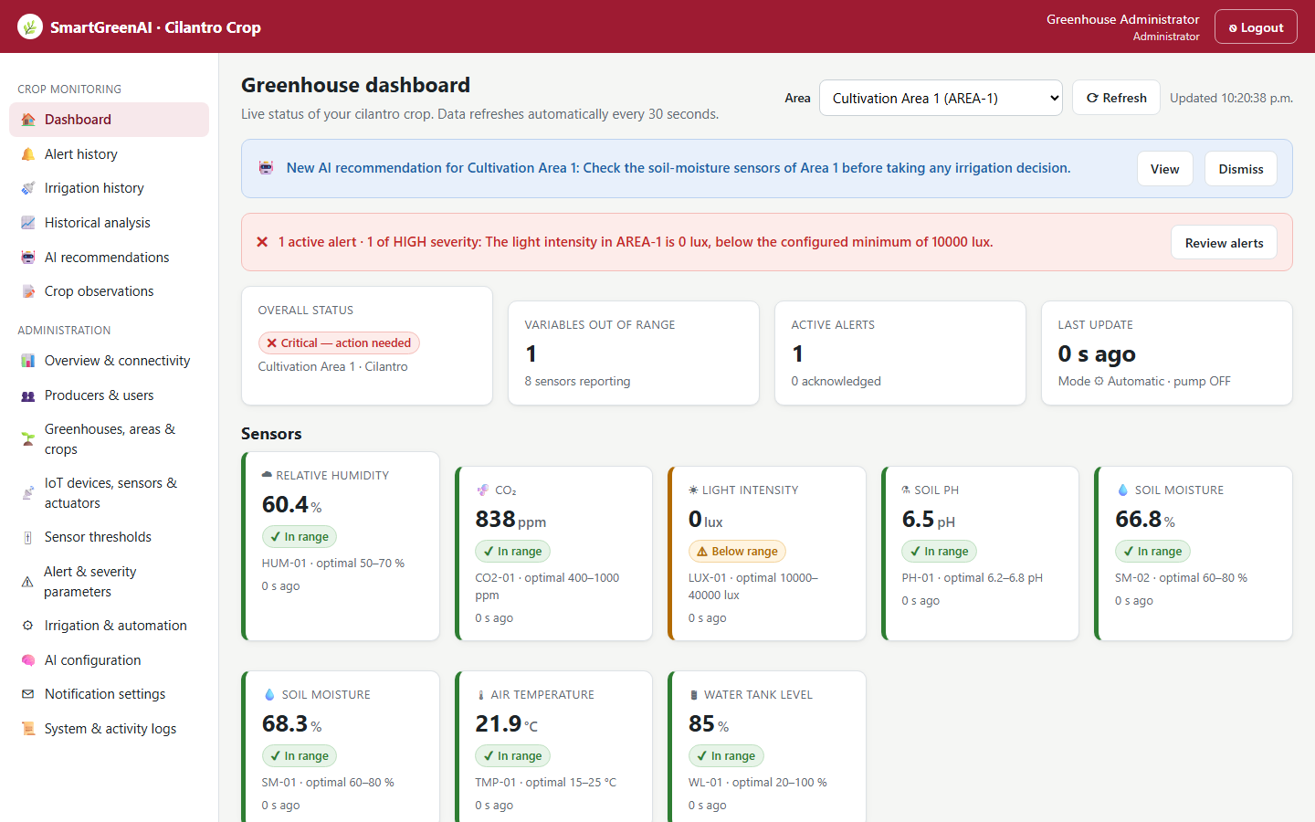
Figure SPR-T1-2. Step 2–3 — readings transmitted by the simulator (US-06) and stored (US-07) appear on the dashboard with their time. (Sprint2_SPR-T1_End-To-End_Integration_Test_3.png)
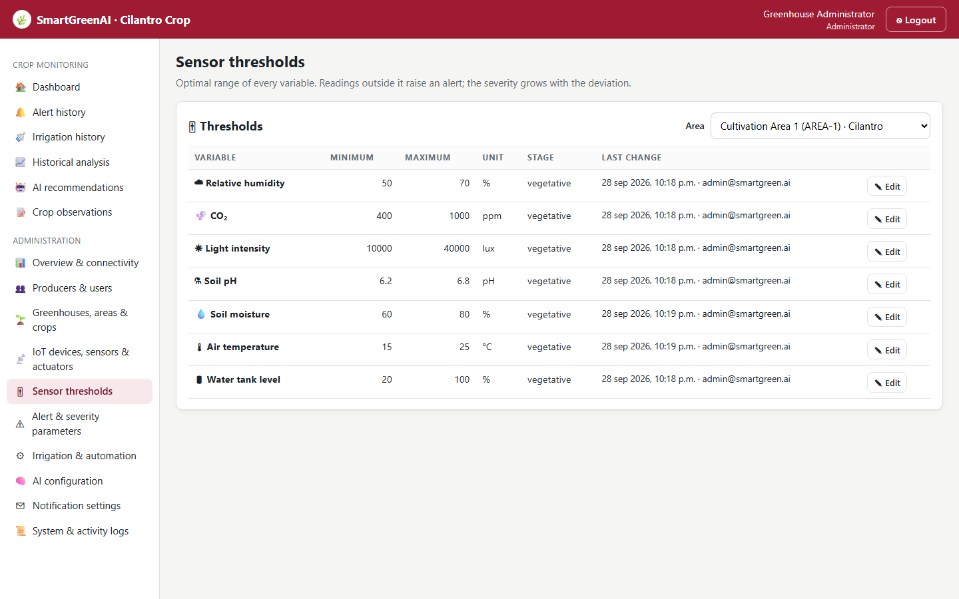
Figure SPR-T1-3. Step 4–5 — the API (US-08) serves the threshold screen (US-10). (Sprint2_SPR-T1_End-To-End_Integration_Test_4.png)
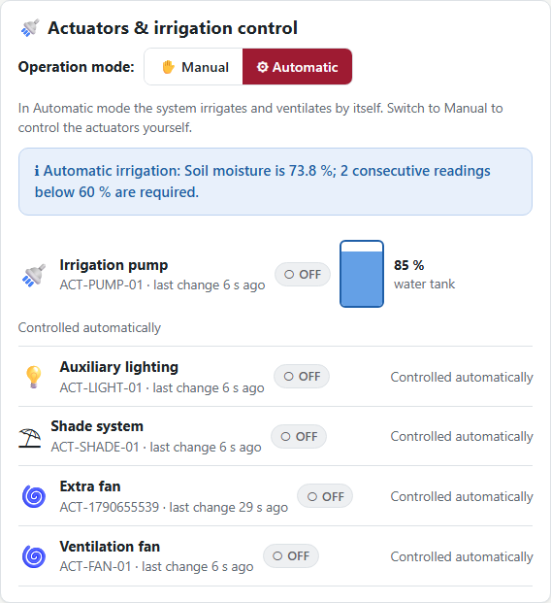
Figure SPR-T1-4. Step 6 — the actuator status panel (US-14). (Sprint2_SPR-T1_End-To-End_Integration_Test_5.png)
API step: history of SM-01 (attached: Sprint2_SPR-T1_End-To-End_Integration_Test_7.txt)
GET /api/sensors/SM-01/measurements?limit=3
Authorization: Bearer eyJhbG…
→ HTTP 200 OK (15 ms)
{
"sensor_id": "SM-01",
"type": "soil_moisture",
"unit": "%",
"area_id": "AREA-1",
"count": 3,
"data": [
{
"value": 68.3,
"unit": "%",
"recorded_at": "2026-09-29T04:20:37.959Z",
"received_at": "2026-09-29T04:20:37.975Z",
… (21 more lines in the attached file)

Simulator run during the integration test (attached: Sprint2_SPR-T1_End-To-End_Integration_Test_2.log)
SmartGreenAI simulator · scenario "normal" · every 3 s · speed x1 · API http://localhost:3000/api
04:20:34 → 8/8 readings stored in 140 ms | soil 67.7/66.6 % temp 22 °C tank 85 % | anomalies: SUDDEN_JUMP
04:20:38 → 8/8 readings stored in 119 ms | soil 68.3/66.8 % temp 21.9 °C tank 85 % | 1 new alert(s)
=== Delivery report (US06-T5) ===
cycles: 2 · readings generated: 16 · accepted by the API: 16 · rejected: 0
success rate: 100.0 % · average round-trip: 130 ms · max: 140 ms
failed attempts: 0 · readings that went through the buffer: 0 · dropped (buffer full): 0 · still buffered: 0

✓ Condition 2: Every team member participated with their part working.
How it was verified: Every story of the sprint took part through its owner's component: US-01-C (Alexis, login and roles used by every step), US-06 (Vicente, simulator), US-07 (Oscar, storage), US-08 (Carlos, API), US-10 (Jorge, thresholds), US-14 (Oscar, actuator panel), US-25 (Alexis, registry).
✓ Condition 3: Video/screenshots saved and defects registered on the board.
How it was verified: Video of the run (Sprint2_SPR-T1_End-To-End_Integration_Test_6.webm) and screenshots are saved; the defects found during integration and testing are listed below with their resolution (also recorded in docs/TEST_PLAN.md).
Defects found
ID | Story | Defect | Resolution | Status
D-01 | US-01-C | Login audit crashed: the request object was copied with {...req} and lost Express methods | Fixed: audit reads IP from headers; controller passes a request prototype | Fixed and retested (auth tests)
D-02 | US-14 | Idle actuators of a connected device were shown OFFLINE | Fixed: the heartbeat reports the actuator states (agreed with Vicente in Daily Meeting 3) | Fixed and retested
D-03 | US-06 | Payload could not carry device_id (required by US06-T1) | Fixed: optional device_id validated against the API key | Fixed and retested (measurement tests)
D-04 | US-07 | Readings rejected for schema errors were not written to the system log | Fixed: WARN entry for every rejection | Fixed and retested
D-05 | US-07 | include_anomalies=false was read as true | Fixed: explicit true/false parsing | Fixed and retested
600,900,3400,2900,1560
✓ Condition 4: Evidence: Integration video / screenshots and list of defects found.
How it was verified: Integration video, step screenshots and list of defects.

4. Attached files
- Sprint2_SPR-T1_End-To-End_Integration_Test_1.png
- Sprint2_SPR-T1_End-To-End_Integration_Test_2.log
- Sprint2_SPR-T1_End-To-End_Integration_Test_3.png
- Sprint2_SPR-T1_End-To-End_Integration_Test_4.png
- Sprint2_SPR-T1_End-To-End_Integration_Test_5.png
- Sprint2_SPR-T1_End-To-End_Integration_Test_6.webm
- Sprint2_SPR-T1_End-To-End_Integration_Test_7.txt

5. Traceability
Related requirements | All requirements of the sprint
Implementation | See docs/TRACEABILITY.md
Verification | See docs/TRACEABILITY.md

6. Sign-off
Role | Name | Date | Signature
Responsible | Whole team (facilitated by Jorge) | October 8, 2026
Peer reviewer | Whole team | October 8, 2026
Product Owner acceptance | Alexis Enrique Valle Parra | October 8, 2026
Approval record: Sprint 2 Review & Delivery (October 9, 2026): "Product Owner accepted the seven user stories: all acceptance criteria met." Daily Meeting 3 planned SPR-T1 for Thursday, October 8.

